Cairo University  
Faculty of Computers and Information



**CS251**

**Software Engineering I**

Project Name

Software Design

Team Names

Month & Year

Contents

Instructions [To be removed] 3

Team 3

Document Purpose and Audience 3

System Models 3

I. System Decomposition 3

II. Class diagrams 6

Important Algorithm 7

III. Sequence diagrams 7

Class - Sequence Usage Table 9

Ownership Report 10

Policy Regarding Plagiarism: 10

References 10

Authors 10

# Team

|  |  |  |  |
| --- | --- | --- | --- |
| **ID** | **Name** | **Email** | **Mobile** |
| **20170041** | Osama Tarek Mohamed | Osamatarek290@gmail.com | **01100405217** |
| **20170012** | Ahmed Ayman Abd-Elfattah | Ahmed.ayman16899@gmail.com | **01019139159** |
| **20170024** | Ahmed Abd-Elnaby fouad | Ahmedalsaket011@gmail.com | **01026731836** |
| **20170004** | Abo-Taleb Khaled Abo-Taleb | Abotalebkhaled222@gmail.com | **01069857991** |

# Document Purpose and Audience

* **This document describes the system decomposition, class diagram and sequence diagrams for a specific system to be illustrated.**
* **Mainly the targets of that document are: Developers – Analysts.**

# 

# System Models

## I. System Decomposition

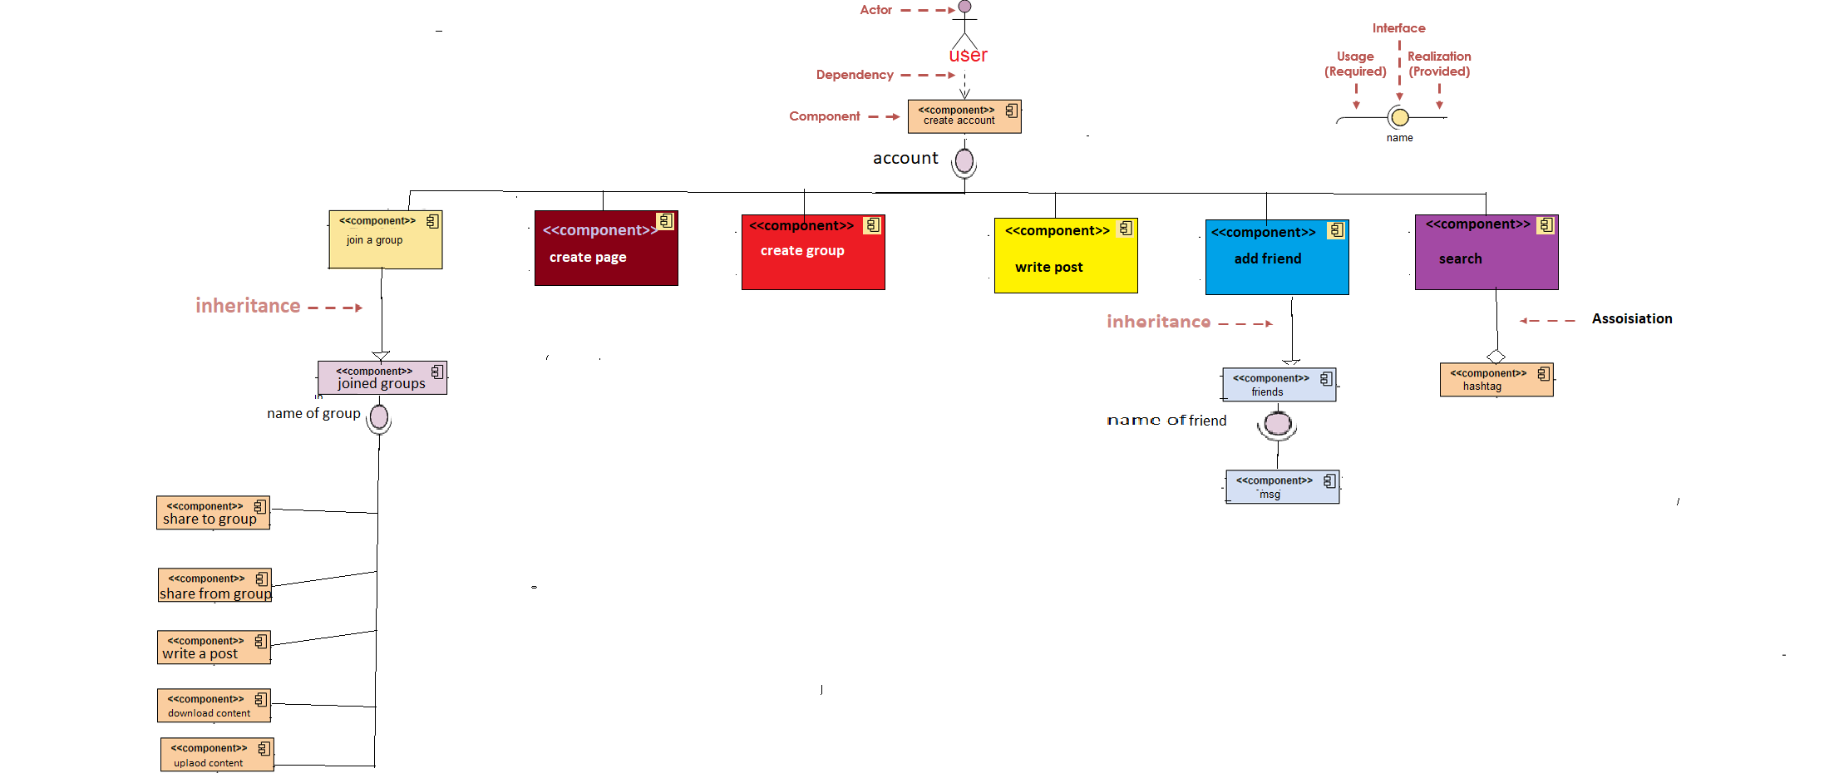

## II. Class diagrams

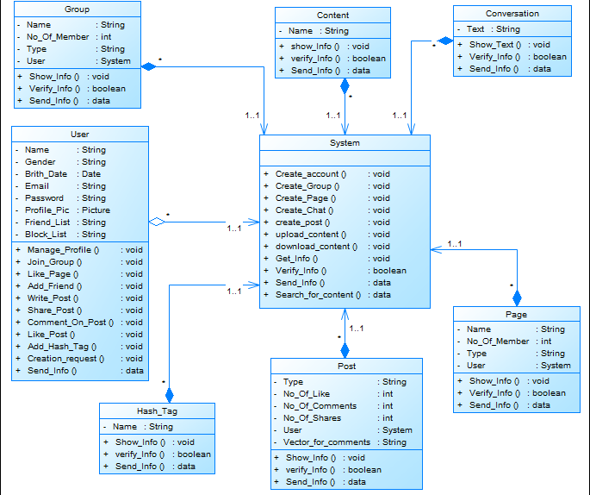

| **Class ID** | **Class Name** | **Subsystem ID** | **Description & Responsibility** |
| --- | --- | --- | --- |
| 1 | System | None | The only class that the user interacts with.  It should do all the user’s commands. |
| 2 | User | None | This class devoted for the user. It provides the most functions that the user wants to interact with the system. |
| 3 | Content | None | This class used by the system when the user wants to search for anything. |
| 4 | Group | None | The group class contains information about groups and validation function in case of creating a new group |
| 5 | Hash_Tag | None | The hashtag responsibility is to categorize posts in any kind. Used by the user in case of searching for a specific thing. |
| 6 | Conversation | None | Its responsibility is to show text messages among users. |
| 7 | Page | None | The page class contains information about created pages and validation function in case of creating a new page with given audience and purpose. |
| 8 | Post | None | Mainly it shows the content of specific post to the user to interact with. |

## 

## III. Sequence diagrams

**ID = 1, Use Case: Write a post.**

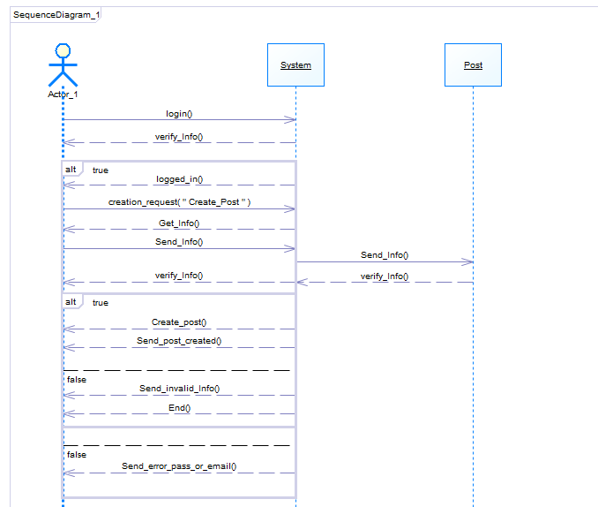

### 

**ID = 2, Use Case: Create Account.**

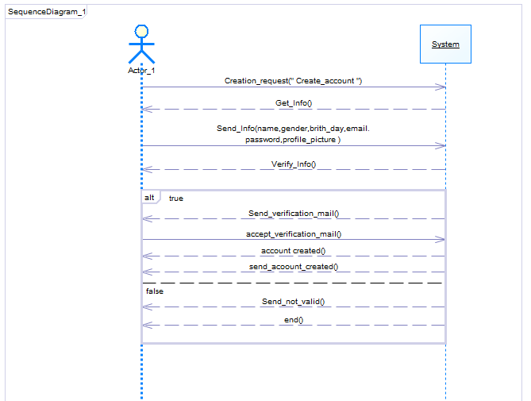

**ID = 3, Use Case: Upload Content.**

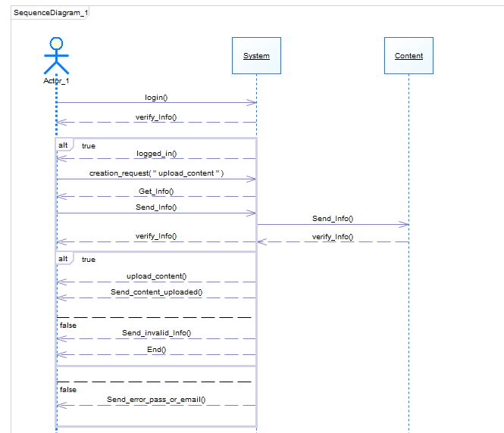

**ID = 4, Use Case: Search for Content.**

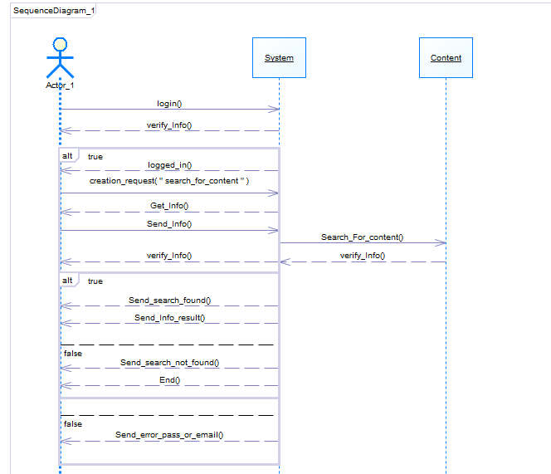

**ID = 5, Use Case: Create Group.**

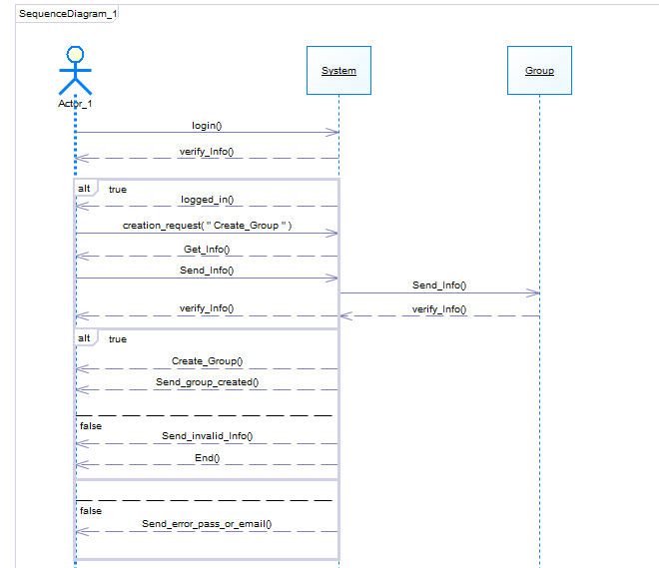

**ID = 6, Use Case: Using Hash Tag.**

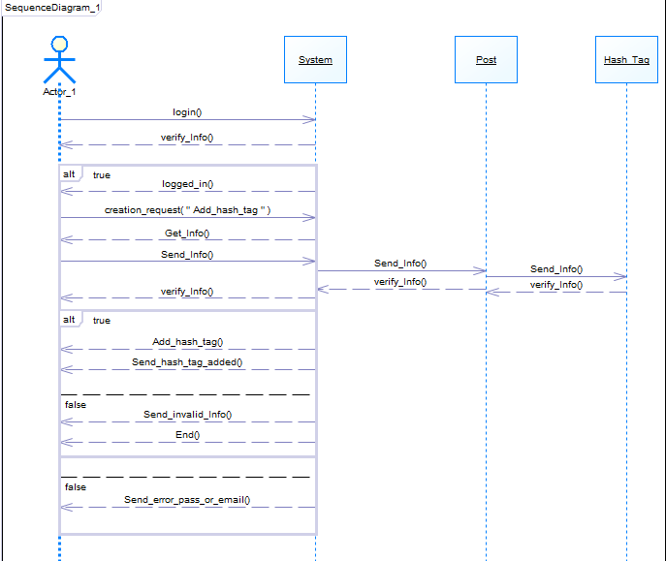

**ID = 7, Use Case: Download Content.**

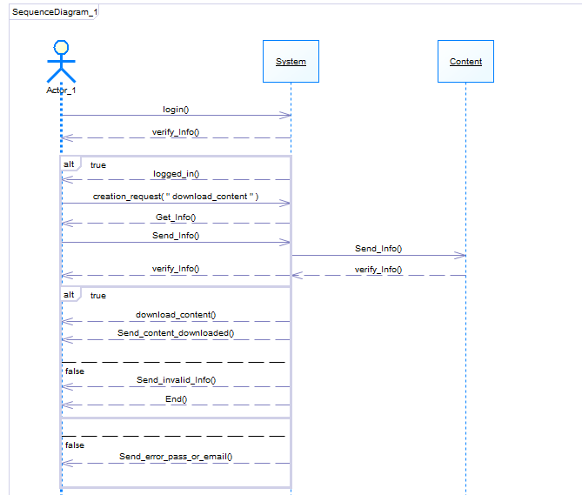

**ID = 8, Use Case: Create Page.**

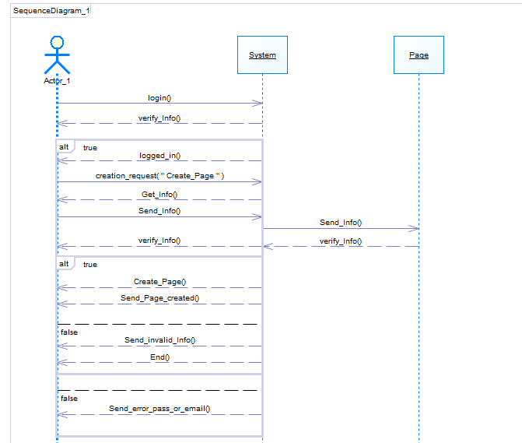

### Class - Sequence Usage Table

| **Class Name** | **Sequence Diagrams** | **Overall used methods** |
| --- | --- | --- |
| User | 1,2,3,4,5,6,7,8 | Creation request, send data, add_Hash_tag, send_info, write_post. |
| System | 1,2,3,4,5,6,7,8 | Create_page , create_ group , create_post, Verify_info, upload_content, download_content, send_info and get_info. |
| Post | 1_6 | Verify_info |
| Page | 8 | Verify_info |
| Group | 5 | Verify_info |
| Content | 3-4-5 | Verify_info |
| Hash_Tag | 6 | Verify_info |

# 

# Ownership Report

|  |  |
| --- | --- |
| **Item** | **Owners** |
| Component diagram | *Ahmed Alsaket and Ahmed Ayman* |
| Class Diagram and sequence diagrams | *Abotaleb Khaled, Osama Tarek* |

# 